BDI 475 - Spring 2026
Final Group Project
Rufat Miriyev, Hannah Ip, Alex Ji

Background:
As countries continue pursuing net-zero carbon goals and long-term energy security, nuclear energy has reemerged as a major topic within the global clean energy transition. Unlike fossil fuels, nuclear power produces low-carbon electricity while also providing stable baseload energy generation. Because of this, many governments and investors have begun reconsidering nuclear energy as part of future decarbonization strategies. At the same time, nuclear energy remains controversial due to concerns regarding construction costs, project delays, waste disposal, and negative public perception following historical nuclear disasters.

Investment debate:
The debate surrounding nuclear energy is not only environmental but also financial. Supporters argue that nuclear energy represents a reliable long-term investment capable of supporting clean energy goals and improving energy security. Critics, however, argue that nuclear projects often experience major cost overruns, regulatory uncertainty, and long payback periods that create significant financial risk. Public perception also plays an important role, as investor confidence and government policy are often influenced by media coverage and public opinion.

Business question: Is nuclear energy a worthwhile clean energy investment, or is it a potential financial risk due to negative public perception?
This question sits at the intersection of energy finance, ESG investing, and public sentiment analysis. As global capital increasingly flows toward clean energy, nuclear power occupies a uniquely contested position — praised for its low-carbon output but scrutinized for cost overruns, public opposition, and long-term liability. Understanding how financial media and news sources frame nuclear energy is therefore critical for investors, policymakers, and corporate strategists navigating the energy transition.

Search query: ("nuclear energy" OR "nuclear power plant*" OR "small modular reactor*" OR SMR) AND (invest* OR "capital cost*" OR "cost overrun*" OR "levelized cost" OR financ* OR subsid* OR "rate of return") AND (risk* OR "public perception" OR "public opposition" OR "social license" OR ESG OR "stranded asset*" OR viability OR competitiveness) AND ("clean energy" OR "low-carbon" OR "energy transition" OR "net zero" OR decarbonization)

Filters:
- Date: 5 years
- Source type: Newspapers

GPT text analysis prompt:
- Read the following article and determine whether nuclear energy is a worthwhile clean energy investment or a potential financial risk. Answer with one word only: worthwhile or risk, or if the article is unrelated to this topic answer "unrelated."
- Answer: majority worthwhile
- 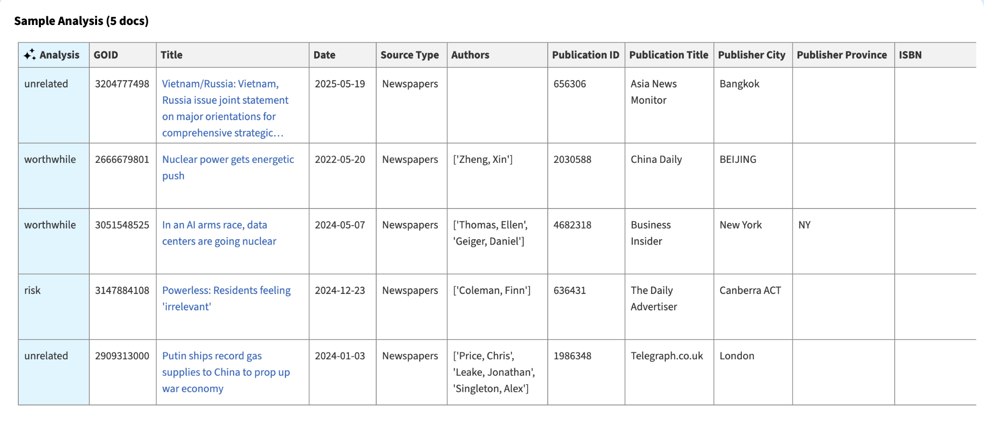

Findings
- Overall, nuclear energy is a worthwhile investment, but it does present some financial risk worth noting (see python analysis for more detail).
- 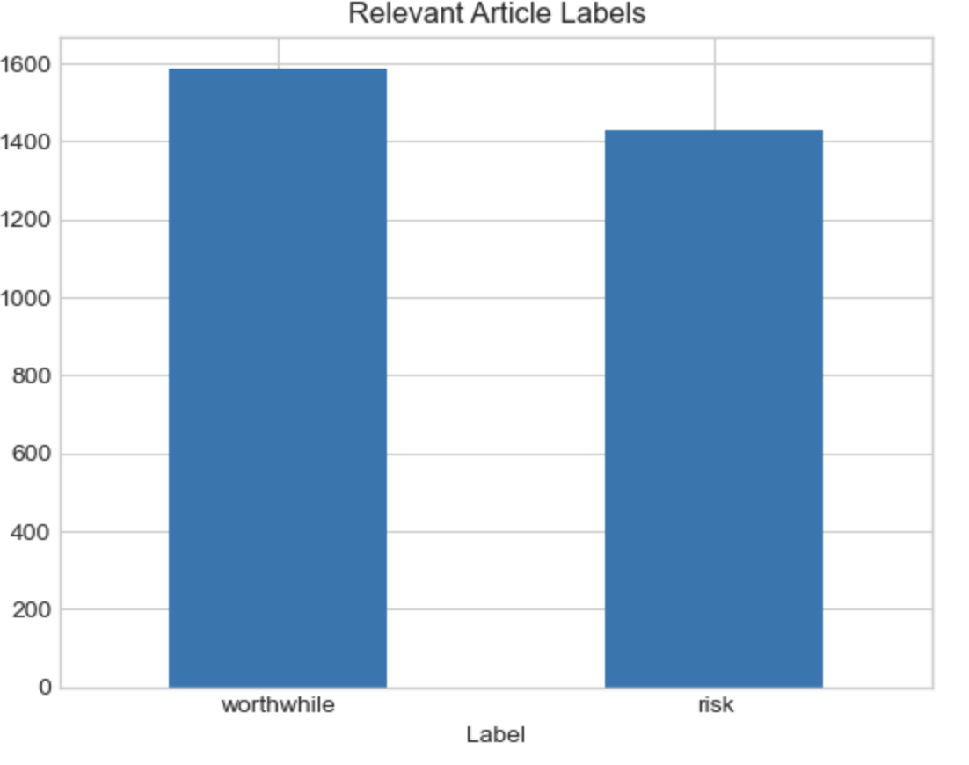
- Nuclear energy is framed slightly more as worthwhile than risky, but the margin is small enough where people should still be aware of the risks
- Analysis suggests that nuclear energy investment sentiment is heavily dependent on changing markets and policy conditions. However, starting from 2025, the margins between worthwhile and risk have increased, suggesting that overall sentiment may switch to ‘worthwhile’ in the future.
  - 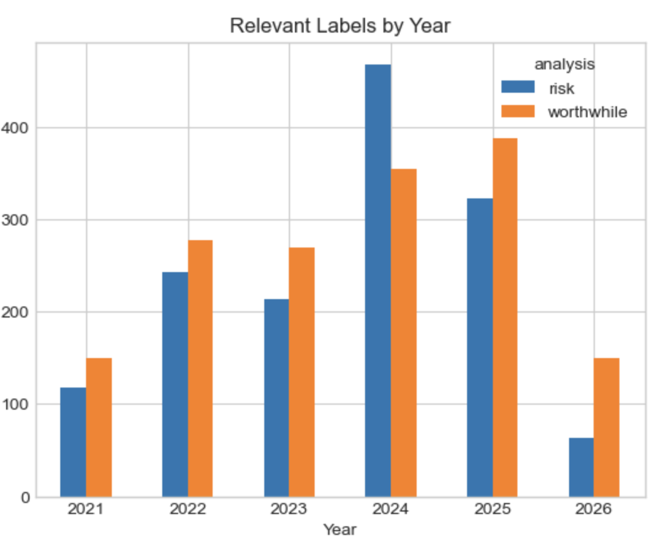
- Asian news and article sources have a greater number of articles believing nuclear energy is a worthwhile investment, suggesting that sentiment is dependent on geographical location.
  - 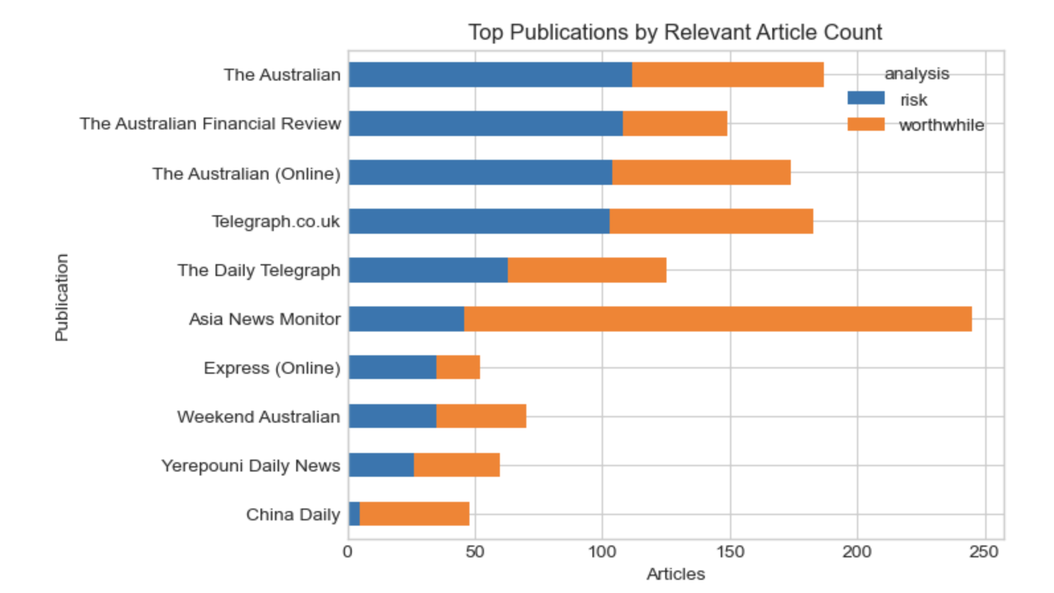

Overall, the analysis suggests that nuclear energy is increasingly viewed as a worthwhile clean energy investment, although substantial financial risks and public perception concerns remain. While the overall sentiment was only moderately positive, trends after 2025 indicate growing optimism regarding nuclear energy’s long-term role within the clean energy transition.
The analysis also revealed significant regional differences, with Asian publications framing nuclear investment more positively than many Western sources. Furthermore, emerging technologies such as small modular reactors appear to be improving investor confidence by addressing some of the financial concerns traditionally associated with nuclear energy projects.
Despite these positive trends, concerns regarding cost overruns, construction delays, and regulatory uncertainty continue to create meaningful investment risk. As a result, the future success of nuclear energy investment will likely depend on continued technological innovation, stable government policy support, and the ability to improve public trust and financial execution.

